Software Requirements Specification

Milestone 1 – Mobile Team

Software Engineering Project

SWEN 670

February 2, 2021

Presented by: Sylvia Lopez-Willis, Bertina Lee, Brian Malott,

Karim Mansour, Komi Noukafou, Sompon Boontho,

Joselito Ocampo, Ermias Seyoum, Arnaud Tako, Alex Dattilio

Revision History

|  |  |  |  |
| --- | --- | --- | --- |
| DATE | VERSION | DESCRIPTION | AUTHOR |
| 02/01/2021 | 1.0 | Initial documents | Sylvia Lopez-Willis,  Bertina Lee,  Brian Malott,  Karim Mansour,  Komi Noukafou,  Sompon Boontho |
| 02/23/2021 | 1.1 | Updates to document | Sylvia Lopez-Willis,  Bertina Lee,  Brian Malott,  Karim Mansour,  Komi Noukafou,  Sompon Boontho |
| 03/16/2021 | 1.2 | Updates to document | Sylvia Lopez-Willis,  Bertina Lee,  Brian Malott,  Karim Mansour,  Komi Noukafou,  Sompon Boontho,  Joselito Ocampo,  Ermias Seyoum,  Arnaud Tako,  Alex Dattilio |

Table of Contents

1. Introduction 4

1.1 Purpose 4

1.2 Scope 4

1.3 Definitions, Acronyms, and Abbreviations 5

1.4 Risk Analysis 5

1.5 Overview 6

1.6 References 6

2. Overall Description 6

2.1 Use-Case Model Survey 7

2.2 Data Flow Diagram 7

2.3 System Evolution 8

3. Specific Requirements 9

3.1.1 Use Case Name: Sliding Menu 9

3.1.2 Use Case Name: Login 10

3.1.3 Use Case Name: Logout 14

3.1.4 Use Case Name: Begin Conversation Session 16

3.1.5 Use Case Name: Specify a Form Template to Form Scriber 18

3.1.6 Use Case Name: Specify “New Prescription” to Form Scriber 22

3.1.7 Use Case Name: Specify “Medical History” to Form Scriber 24

3.1.8 Use Case Name: Request Report 27

3.1.9 Use Case Name: View Reports 29

3.1.10 Use Case Name: View Settings 31

3.1.11 Use Case Name: View Help 32

# 1. Introduction

The mobile development team will create an artificial intelligence (AI) mobile application for its customers. The customer will fill out a text report after performing a portion of their job upon the completion of meeting with a patient or person that is being interviewed. The AI mobile application will listen to the conversation between the customer and interviewee (example: patient). Once the AI application has listened to the conversation, the app will prepare notes that will allow the customer to edit before saving it in an Electronic Medical Record (EMR) or, depending on the customer, a similar system.

## 1.1 Purpose

The purpose of this SRS is to document the requirements for the AI Mobile Application, Form Scriber. The target launch date for the mobile application is set for April 6, 2021. The graduate students for the MSIT Software Engineering Project 670 course Mobile Team will create the mobile application.

The following Use Cases will be created and can be referenced in Section 3.

1. Sliding Menu
2. Login
3. Logout
4. Begin Conversation
5. Specify a Form Template to Form Scriber
6. Specify “New Prescription” to Form Scriber
7. Specify “Medical History” to Form Scriber
8. Request Report
9. View Report
10. View Settings
11. View Help

## 1.2 Scope

Create an artificial intelligence (AI) mobile application for customers geared toward doctors, medical technicians, police officers, and others in similar fields. The mobile application will be created in Android Studio using Flutter, a Google UI toolkit for creating an Android and iOS mobile application. The Dart programming language developed by Google to be used with Flutter will allow using one programming language to make the mobile application a cross-platform for iOS and Android.

The mobile application will listen to the conversation between the customer and their patient (interviewee) and prepare notes that the customer will then be able to edit before saving it in an Electronic Medical Record or another similar tool the customer uses.

The mobile application will use a tool that will take guidance from the customer about how they want to see the end report. The device will create a template that can be used at a later time during the customer conversation with the interviewee. The template will have multiple elements that the Artificial Intelligence (AI) part of the mobile application will work on and fill in the required information as the conversation progresses.

The Agile methodology will be used with the Scrum framework.

Work within the scope of the project and what will be done:

* The mobile application (component) will do the sound capture and participate in processing.
* Google Cloud Platform (GCP), and its AI tools will be used. A new sign-up with GCP will be done that gives a $300 credit to use within three months.
* A chatbot service called DialogFlow offered to power the system.
* Testing will be done on the mobile application to ensure it is ready before the launch date (completed by the set Capstone Project deliverable date).
* Support documentation and download instructions for the Help section of our mobile application.

Work outside the scope of the project that will not be done:

* No AI models will be developed.

## 1.3 Definitions, Acronyms, and Abbreviations

This SRS document will use terms related to mobile application development, other SWEN 670 course Capstone Project, and customer-requested features.

|  |  |
| --- | --- |
| Abbreviations, Definitions, Acronyms | Definition |
| GCP | Google Cloud Platform |
| AI | Artificial Intelligence |
| API | Application Programming Interface |
| Form Scriber | Name of the application solution. |
| DevSecOps | Developer Security Operations |

## 1.4 Risk Analysis

Risks can be found in the project if requirements are misinterpreted or documented incorrectly. All requests from the customer and Dr. Mir Assadullah should be well documented and communicated in this SRS. If the SRS is not well documented with proper requirements, it can fail or not meet the project deliverable date.

Other risks that follow can be creating a mobile application that does not meet public service professionals' needs by completing an application that is not user-friendly. This will cause a disinterest to the customer, resulting in an unusable product.

## 1.5 Overview

This SRS has been created as part of the requirements document to develop an artificial intelligence (AI) mobile application to support our customers that include doctors, medical technicians, police officers, and others. The SRS currently has eleven use cases that are expected to grow as the project progresses. Use cases will include tables and screenshots to elaborate on the project. Besides the use cases, the SRS document includes purpose, scope, risk, and descriptions.

## 1.6 References

|  |  |
| --- | --- |
| Title | Reference |
| The 2020 Scrum Guide | <https://www.scrumguides.org/scrum-guide.html#increment> |
| Kick-Off Meeting, SWEN 670, Software Engineering Project, Course Homepage | <https://learn.umgc.edu/d2l/home/545048> |
| Project Plan Mobile Team | Sylvia Lopez-Willis |

# 2. Overall Description

The mobile app team's goal is to create a mobile application that will allow a user to fill out a form one field at a time through voice recording. The mobile application begins the process by authenticating a user with the Landing page that includes Google sign-in. Once the user is authenticated, the main menu will open. Navigating to the “Report capture” page, the user may select a form template document they are authorized to use. This template document is then duplicated to protect against template overwrites. The duplicated document is provided to DialogFlow to create intents that will match the user’s audio capture of form fields. The user will then use Google Assistant to capture each form field individually and see the response returned from DialogFlow’s processing of the audio captured. DialogFlow will record each captured field to the document it was provided, and the user can view the updated document in their Google Drive account. Navigating to the “Help” page, the user can review help information by clicking on the links to HTML help pages which will open in a containerized browser. Navigating to the “Application settings” page, the user can review and edit the app's aesthetics, such as color and text size.

The mobile app will consist of two components:

1. The user interface
2. The business logic

## 2.1 Use-Case Model Survey

The AI Mobile Application has eleven use cases as described in the table below:

|  |  |
| --- | --- |
| Use Case | Description |
| Sliding Menu | The user swipes left to right to see the sliding menu options. |
| Login | The display and functionality of logging a user into the system. |
| Logout | The display and functionality of logging a user out of the system. |
| Begin Conversation | Connects to Form Scriber to initiate communication. |
| Specify a Form Template to Form Scriber | Sends form URL of the selected template to Form Scriber. |
| Specify “New Prescription” to Form Scriber | Sends form id for “New Prescription” to Form Scriber. |
| Specify “Medical History” to Form Scriber | Sends form id for “Medical History” to Form Scriber. |
| Request Report | Sends form URL of the selected template to Form Scriber. |
| View Reports | Displays report history. |
| View Settings | Displays and sets settings. |
| View Help | Displays application’s help system. |

## 2.2 Data Flow Diagram

The data flow diagram below describes how the overall system will connect and communicate between internal and external components.

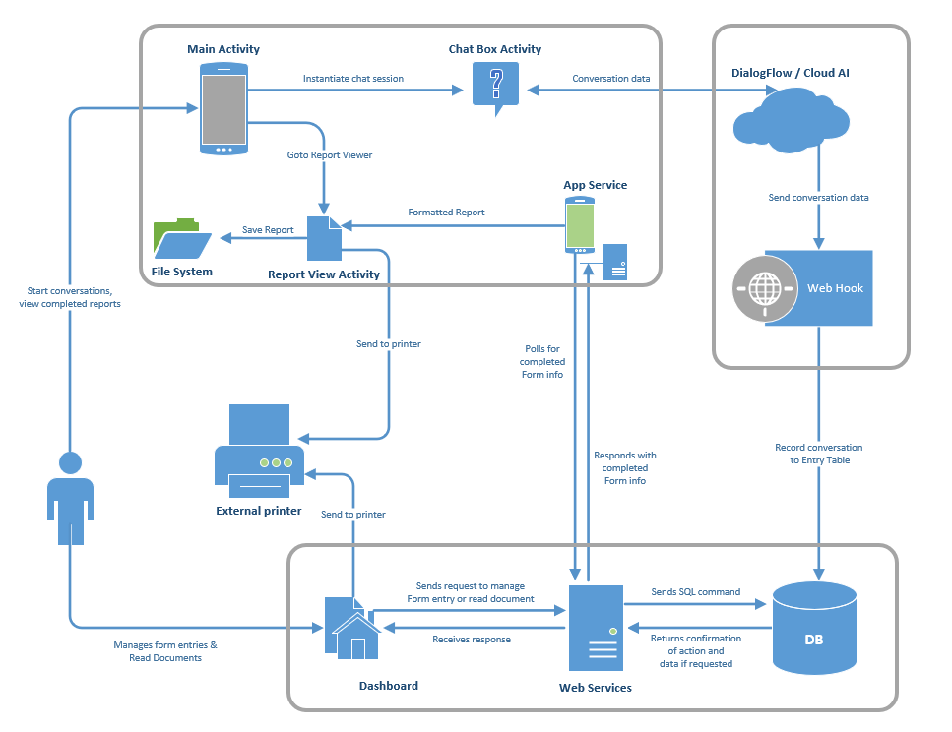

## 2.3 System Evolution

The Form Scriber, AI mobile application, will be used by public service professionals allowing them to prepare a text report. The expected launch date is set for April 6, 2021. The mobile application will be offered in Android and iOS mobile applications through the Google Play Store and App Store.

2.4 Software SME

Subject Matter Experts will be interviewed and consulted on the SRS Use Cases. This will allow the development process to meet requirements and get feedback from the SME. Since the service professionals are the authority for their field and know what they are looking for to make their job easier. Thus, a medical field service professional will be the first SME to consult and be shown the Use Cases. The Mobile Team will reach out to other channel teams to find SMEs from other service fields. Feedback will be documented and compared to the software requirements. If a feature is missing, then the mobile team, through documentation, will address the feedback and present the changes to the overall project Stakeholder for approval of the Change Management Plan referenced in the Project Plan.

# 3. Specific Requirements

This portion of the document will detail all eleven use case reports, including features of the mobile application pages, screenshots, and actors.

3.1 Use-Case Reports

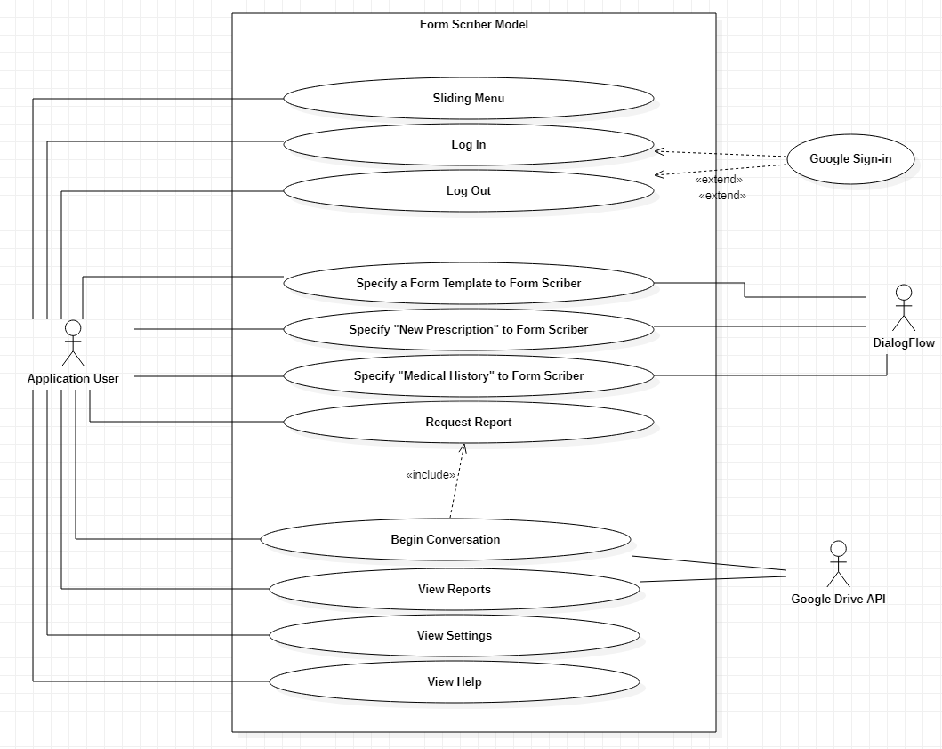

*Figure 3.1: UML Diagram*

### 3.1.1 Use Case Name: Sliding Menu

**Summary:** A sliding menu option for the user to swipe right to left to access the menu options.

**Preconditions:**

* + The user has opened the mobile application and has been authorized.

**Triggers:** The actor will trigger the menu by swiping from right to left to access the menu**.**

**Basic course of events (Scenario):** An authenticated user wants to access the menu options to use the app.

Internal Precondition: The application has been started, and the user has been authenticated.

|  |  |  |
| --- | --- | --- |
| Actor | System | Screen |
| 1. The authorized actor swipes right to left |  |  |
|  | 2. The system displays the menu to allow the user to click on the menu item for the Homepage, Begin Conversation, View Reports, Settings, Help, and Log Out. |  |

### 3.1.2 Use Case Name: Login

**Summary:** The display and functionality of logging a user into the system.

**Preconditions:**

* + The user is already registered.

**Triggers:** The actor will trigger the login event by tapping on the landing page's Login button.

**Basic course of events (Scenario):** A registered user wants to log in to use the app.

Internal Precondition: The application has been started, and the login screen has been presented.

|  |  |  |
| --- | --- | --- |
| Actor | System | Screen |
| 1. The actor taps on the login button on the landing screen. |  |  |
|  | 2. The system will display the login screen with the Username and Password fields. |  |
| 3. The actor enters their Google credentials, username, and password, then taps the login button. |  |  |
|  | 4. The system will validate the credentials. |  |
|  | 5. The system displays the main page. |  |

Alternative paths:

1. The user enters an invalid username and/or password.

Internal Precondition: None

|  |  |  |
| --- | --- | --- |
| Actor | System | Screen |
|  | 3. The system displays an error message indicating that the username and/or password is invalid. |  |
|  | 4. The system remains on the login screen. |  |

### 3.1.3 Use Case Name: Logout

**Summary:** The display and functionality of logging a user out of the system.

**Preconditions:**

* + A user must be logged in.

**Triggers:** The actor will trigger the logout event by tapping on the Logout button from any screen.

**Basic course of events (Scenario):** A user who is logged in wants to logout.

Internal Precondition: The actor is logged into the system. The logout button is presented on the screen.

|  |  |  |
| --- | --- | --- |
| Actor | System | Screen |
| 1. The actor taps on the logout button on any screen. |  |  |
|  | 1. The system will end the session and display a logout confirmation screen. |  |

### 3.1.4 Use Case Name: Begin Conversation Session

**Summary:** Navigate to the “Form Scriber” chatbox activity to begin the conversation session. Connects to Form Scriber to initiate communication.

**Preconditions:**

* + User is logged in.

**Triggers:** The actor will trigger the chat events by tapping the Begin Recording button.

**Basic course of events (Scenario):** A user wants to begin a conversation with Form Scriber to capture audio of data for form entry.

Internal Precondition: The actor has successfully logged into the system.

|  |  |  |
| --- | --- | --- |
| Actor | System | Screen |
| 1. The actor taps the Begin Conversation button on the Main Screen. |  |  |
|  | 1. The system requests a list of available form templates through the Google Drive API, based on the Google Drive repository which the customer has preconfigured. This list populates a DropdownButton menu. The system navigates to the conversation screen and prompts the user to select a template from the drop-down list before they can begin speaking. |  |
| 1. The actor taps on the   drop-down menu | 1. The system reveals a list of available form templates. |  |

### 3.1.5 Use Case Name: Specify a Form Template to Form Scriber

**Summary:**Sends form URL of the selected template to Form Scriber.

**Preconditions:**

* User is logged in

**Triggers:**The actor will trigger the selection before beginning speech communication in the chatbox.

**Basic course of events (Scenario):**The user selects the template by name from the drop-down menu in the Form Scriber chatbox. The system then sends the URL of the template to the Form Scriber DialogFlow agent. The agent responds with a ready message to indicate the start of intent collection.

Internal Precondition:

* + The actor is on the chatbox screen.
  + The customer has set up a directory on their Google Drive

|  |  |  |
| --- | --- | --- |
| Actor | System | Screen |
| 1.The actor selects the form template from the drop-down list. | 2. The system displays the form name on the screen and gets the URL in memory, stored as a String. |  |
| 3. The user clicks “Proceed” | 2. The system sends the form URL corresponding to the selected form name to the DialogFlow agent and receives a response from DialogFlow indicating it’s ready to listen for field input. |  |
| 3. The actor taps the microphone button. | 4. The system starts recording  the audio. |  |
| 1. The actor speaks into their microphone, stating the name of the specific field they want to update. | 1. The system automatically stops recording audio after a standard moment of silence of 2 seconds, converts their audio into text, and sends it to the DialogFlow agent. |  |
|  | 1. The DialogFlow agent responds with a confirmation message that the desired intent is ready to be recorded. |  |
| 1. The user taps the microphone button and speaks the field entry detail to get written. | 9. The system converts audio and sends this message as text to the DialogFlow agent, then receives a response from Dialogflow confirming the specific field was written. |  |

### 3.1.6 Use Case Name: Specify “New Prescription” to Form Scriber

**Summary:**Sends formName for “New Prescription” to Form Scriber.

**Preconditions:**

* User is logged in.

**Triggers:**The actor will trigger the “New Prescription” conversation in the chatbox.

**Basic course of events (Scenario):**User says or selects or types “New Prescription” in the Form Scriber chatbox.

Internal Precondition: The actor is on the Form Selection screen.

|  |  |  |
| --- | --- | --- |
| Actor | System | Screen |
| 1. The actor selects the form from the Form Scriber chatbox suggestion. |  |  |
|  | 2. The system sends the formName corresponding to New Prescription to the DialogFlow agent and receives a response from DialogFlow. |  |
| 3. The actor taps the microphone button. |  |  |
|  | 4. The system starts recording the audio. |  |
| 5. The actor taps the microphone button. |  |  |
|  | 6. The system stops recording the audio. |  |

Page Break

### 3.1.7 Use Case Name: Specify “Medical History” to Form Scriber

**Summary:**Sends form id for “Medical History” to Form Scriber.

**Preconditions:**

* User is logged in.

**Triggers:**The actor will trigger the “Medical History” conversation in the chatbox.

**Basic course of events (Scenario):**User says or selects or types “Medical History” in the Form Scriber chatbox.

Internal Precondition: The actor is on the Form Selection screen.

|  |  |  |
| --- | --- | --- |
| Actor | System | Screen |
| 1. The actor selects the form from the Form Scriber chatbox suggestion. |  |  |
|  | 2. The system sends the formName corresponding to Patient Registration to the DialogFlow agent and receives a response from DialogFlow. |  |
| 3. The actor taps the microphone button. |  |  |
|  | 4. The system starts recording the audio. |  |
| 5. The actor taps the microphone button. |  |  |
|  | 6. The system stops recording the audio. |  |

### 3.1.8 Use Case Name: Request Report

**Summary:**Sends form URL of the selected template to Form Scriber.

**Preconditions:**

* A user has begun a conversation.
* A user has initiated a report session by the form name.
* A user has provided all required form entry data or stated they do not know some of the data to enter.

**Triggers:**The actor will trigger the request report event by successfully completing a conversation within the chatbot.

**Basic course of events (Scenario):**After a conversation session is completed, the user will request a completed report, then Form Scriber will request the URL report from DialogFlow. Form Scriber will then receive the URL report from DialogFlow.

Internal Precondition: The actor is on the chat screen.

|  |  |  |
| --- | --- | --- |
| Actor | System | Screen |
| 1. The user will provide the required data in the conversation in the chatbox. |  |  |
| 2. The user will indicate the request for a completed report by saying “print.” | 2. The system will request the report URL from the DialogFlow agent. |  |
|  | 3. The system will receive the report URL from Dialogflow. |  |

### 3.1.9 Use Case Name: View Reports

**Summary:**Displays report history.

**Preconditions:**

* User is logged in.

**Triggers:**The actor will trigger the view reports event by tapping on the View Reports button.

**Basic course of events (Scenario):** A user wants to view the existing report Docs available.

Internal Precondition: None

|  |  |  |
| --- | --- | --- |
| Actor | System | Screen |
| 1. The actor taps on the View Reports link from the menu navigation. |  |  |
|  | 2. The system requests a list of links to the customer’s designated Google Drive document repository. The system displays the list of reports available to view. |  |

Page Break

### 3.1.10 Use Case Name: View Settings

**Summary:**Displays and sets settings.

**Preconditions:**

* User is logged in.

**Triggers:**The actor will trigger the View Settings event by tapping the link Settings in the menu navigation.

**Basic course of events (Scenario):**A user wants to view and update application settings.

Internal Precondition: The actor is logged into the system.

|  |  |  |
| --- | --- | --- |
| Actor | System | Screen |
| 1. The actor will tap the Settings link in the menu navigation. |  |  |
|  | 2. The system will display the available settings on the Settings screen. |  |

Page Break

### 3.1.11 Use Case Name: View Help

**Summary:**Displays application’s help system.

**Preconditions:**

* None

**Triggers:**The actor will trigger the View Help event by tapping the Help link anywhere in the system.

**Basic course of events (Scenario):**A user wants to view the help menu.

Internal Precondition: None

|  |  |  |
| --- | --- | --- |
| Actor | System | Screen |
| 1. The actor can tap the Help link on the sliding menu in the system. |  |  |
|  | 2. The system displays the help screen. |  |